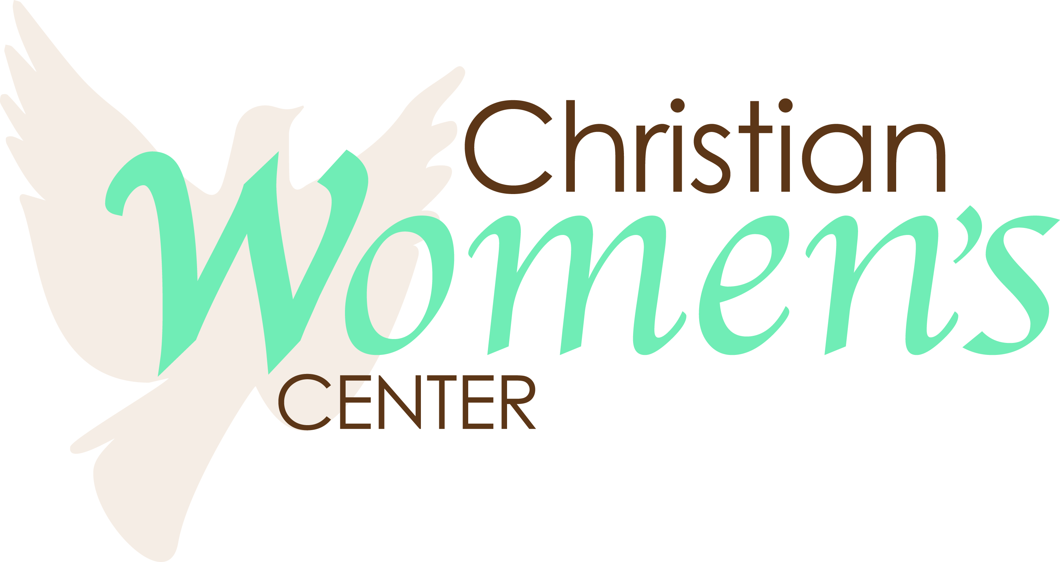
174 School Road
P.O. Box 773
Sunny Side, GA 30284
770-227-3700 (o)
678-888-3842 (f)

Christian Women’s Center Statement of Faith
We believe in one God, self-existent in three Persons: Father, Son and Holy Spirit. We believe in the Bible, God's infallible Word, the whole Word, fully inspired by the Holy Spirit, the supreme authority for faith and practice.
We believe in the deity of God the Son who became the man, Jesus Christ, being conceived of the Holy Spirit and born of a virgin. He lived a sinless life and died a substitutionary death as a complete sacrifice for the sins of all mankind. He arose bodily from the dead and ascended to the right hand of the Father where He is now our interceding Mediator and High Priest.
We believe in the true universal Church as the Body of Christ and Temple of the Holy Spirit. It is composed of all true believers in Christ. It was created by Him for worship and fellowship and is commissioned by Him to publish the Gospel to all the world. Therefore, we embrace the dignity and value of each person and strive to reflect both the unity and diversity of the body of Christ, with standards of conduct based on biblical standards. We believe Christ set an example of baptism, although this is not required to enter heaven. Salvation is by faith alone in the Redemptive Sacrifice of Christ Jesus on the Cross. Baptism is only an outward expression (to others) of what Christ has already done in our hearts. Only through Christ’s blood is there remission of sins. We also believe in once you have been truly saved, you have eternal security through the Grace of God.
We believe that the Holy Spirit is a Divine Person who reveals Christ, both in a ministry to the world by restraining evil and by convicting of sin, and in a ministry to the Church by indwelling, empowering, guiding and teaching all Christians.
We believe that man was made in the image and likeness of God and, by transgression, incurred guilt before God, depravity of soul and spiritual death. We believe in the universal atonement Christ provided for all mankind and that those who repent and believe on Him are justified and regenerated from the guilt and practice of sin. This is the salvation that Christ died to give us.
Our center seeks to honor and obey Jesus Christ, who is present in Spirit and speaks in Scripture, and to advance God’s purposes in the lives of every resident.

