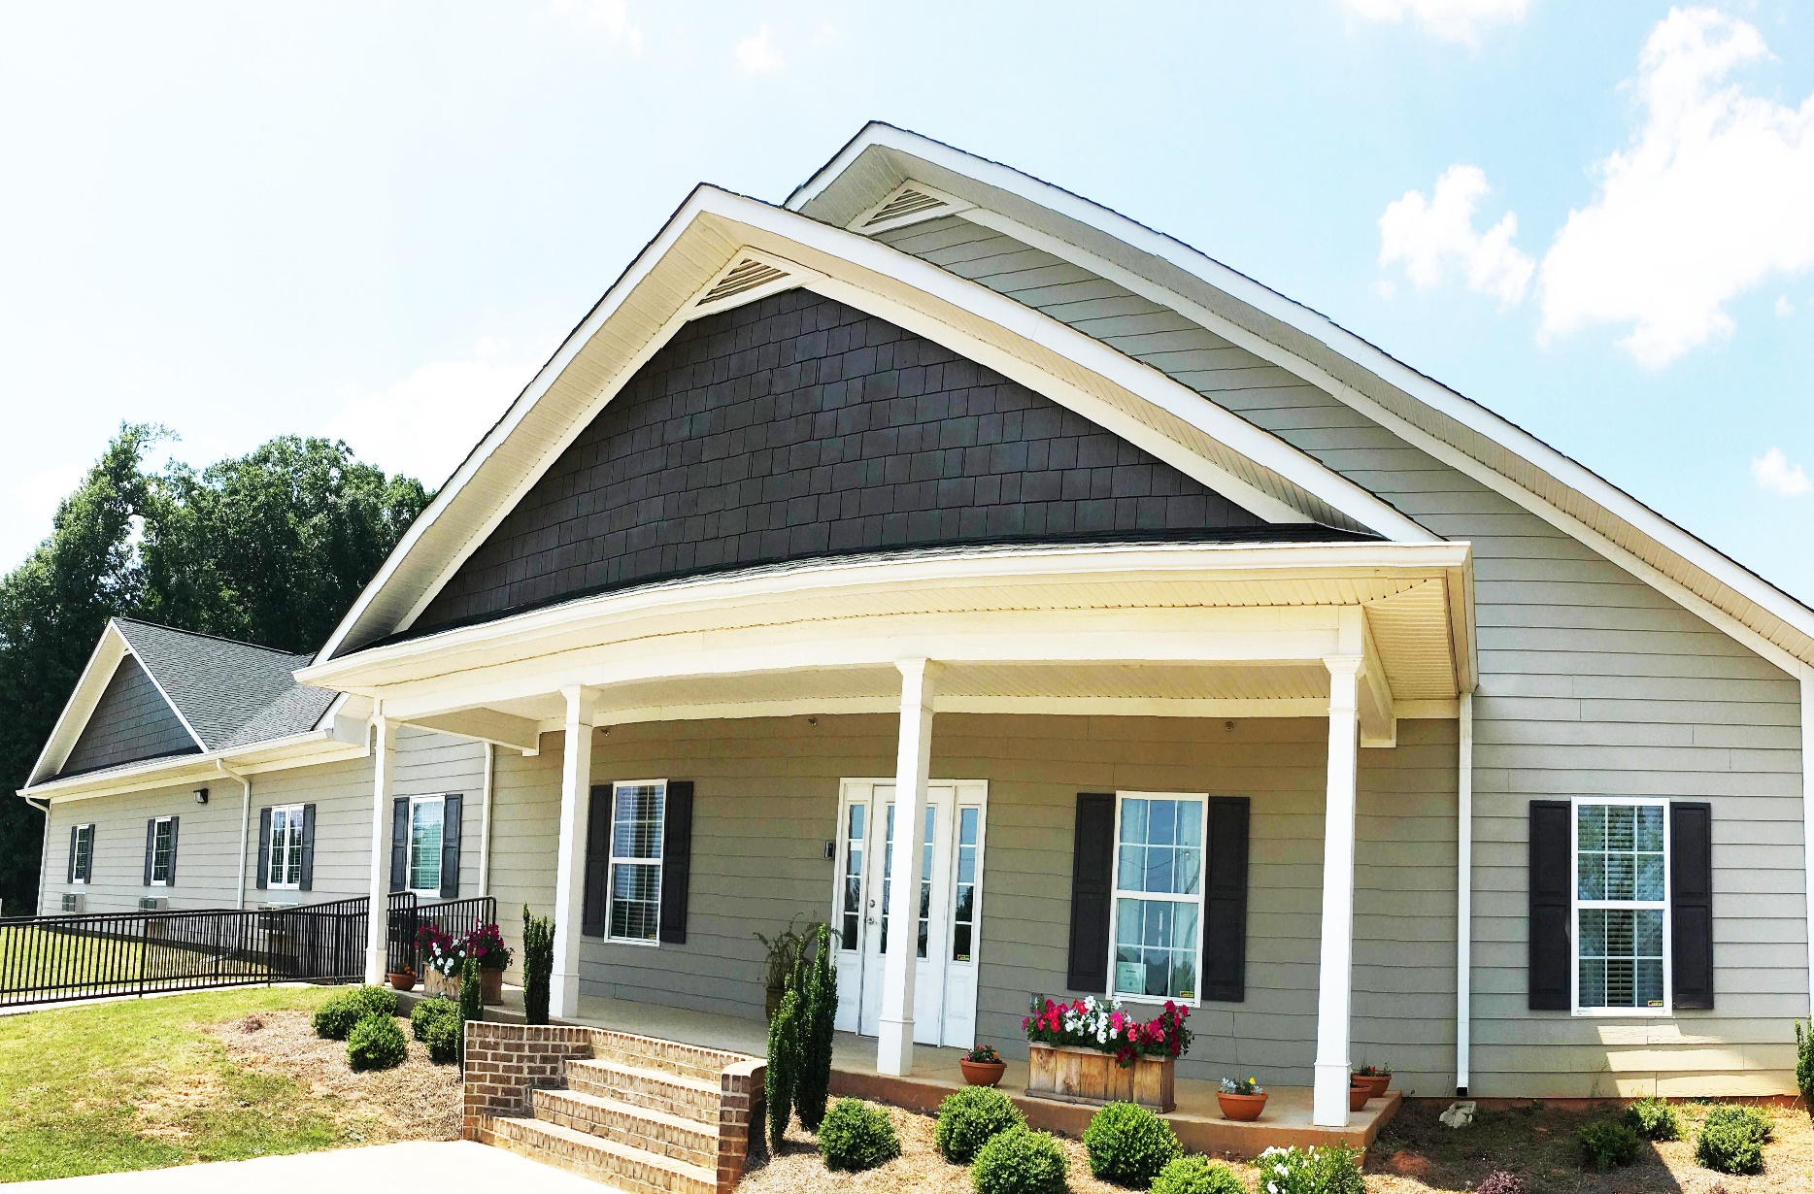
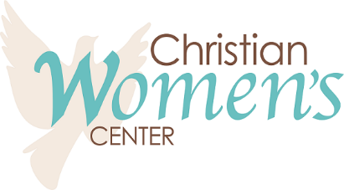

2020
Annual Report

Message from the Executive Director
If seven is the perfect number, then 2021 is going to be amazing! Because my 6th year of ministry was far from perfect. But, what a year it has been.
We could never have known, this time last year, that we would begin a full lockdown in the middle of March…that our store would be closed for 6 weeks…that our residents would experience profound loss…that we would depend so greatly on the goodness of people to meet all of our physical needs…that we would make priceless memories for the record book. One thing we did know…God had His hand all over this ministry and He would make a way no matter the circumstances…and, He did.

We graduated 8 residents AND we finished 2020 with strong giving and a call to retire the debt. I hope you’ll join me as we see what God has in store for 2021. We know the He is faithful and we know that He is able.

Becky Smith
Executive Director
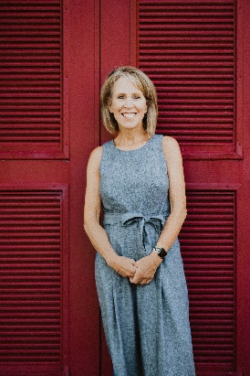

“The mission of the CWC is to provide refuge to women in crisis. Through Christian discipleship, we believe these women can be restore to physical, emotional and spiritual wholeness”
Complete Mission
The Christian Women’s Center opened its doors in 1983 as a shelter for women and children. In 2011, after a tornado hit and destroyed the entire building, the decision was made to rebuild. Around this same time, the members of the Board of Directors were beginning to note that the rate of recidivism they were seeing was disheartening. While the shelter that had been serving the community for over 25 years provided a safe pace for women and their children, day after day showed the same families returning for help without seeing many of them have real hope of life change. In 2013, the decision was made to narrow our focus and become a Residential Discipleship Program for women who found themselves in crisis due to alcohol or drug addiction. The rest is history as the CWC has provided an environment to help restore the lives of many women who were searching for life change.

Women of the Well (WOW Program – Phases 1 & 2)
Our Women of the Well program is the heart of our ministry. After a first contact and detailed interview, our capable staff determines if a woman is ready for life change. In the initial stages of their recovery, our goal is for them to release any worries of hunger and to give them a place to rest their heads at night. We offer a safe and inviting environment for them to begin to focus on healing and restoration, all at no charge. Since we believe that the only way to true healing and restoration is through a relationship with Jesus, our residents are involved in regular Bible studies, provided mentors who pour God’s word and truth into them, and they participate in various church activities. The women are also afforded weekly sessions with Certified Trauma Counseling as well as Certified Addictions Counseling in a group setting. We are also fortunate to have partners (i.e., LifeSong, McIntosh Trail, Impact, Hope Health, and Pathways) in the community who help us provide job and life skills and health and dental care for our residents. The women in our program are also afforded opportunities for recreation and fun through Zumba, walking for exercise, swimming, and an occasional trip to a local movie theater. All household chores, including cooking and lawn maintenance, are done by the residents.

Transition Duplex (Phase 3)
In 2014, through a very generous donor, the CWC was given a duplex in the same neighborhood as the center. Thanks to our ministry partners, it was completely renovated and furnished to be used as a transition home for those program graduates who meet the eligibility criteria. After the dedication of the home, the first graduates moved in January 2015. We believe God provided this residence so that our graduates could have an inexpensive place to transition back into life, as well as a safe place with accountability. With minimal rent, our residents can save toward their future of independent living. As of the end of 2020, we had 1 woman living in the duplex and 3 anticipating moving in Jan, Feb and April.
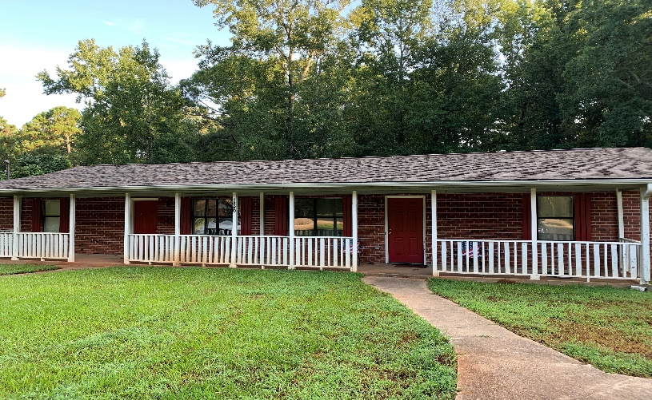

Work Program (Phase 1 & 2)
The Christian Women’s Center is fortunate to have two Thrift stores that help to fund portions of the ministry budget. The CWC Thrift Store and Thrifty by Design Boutique also provide opportunities for our residents to give back through volunteering and/or be a part of our “work program”. When a resident has been in our program for 1 month, they are asked to “give back” by working as a volunteer in roles not typically filled by an employee. After 4 months, our residents have an opportunity to be gainfully employed by these stores (no more than 2 days per week). The women gain job skills and pride knowing that they are contributing to the cost associated with their recovery. For those with felony convictions, our stores can provide a much-needed job and a chance to build a resume for future opportunities. As of December, 2020, we had 4 resident working in our thrift stores through our work program. Our general manager is a graduate of the WOW program. We also partner with other organizations that give our residents job opportunities (i.e. Crestview Baptist).

Program’s Impact
The Christian Women’s Center Women of the Well program offers many services to our residents, including, but not limited to:

Biblical Studies: We have volunteers, many with a scholarly understanding of the scriptures, who teach our residents on a weekly basis. These studies include both topical and exegetical methods. Some of our studies include The Heart of the Problem, The Joy of Repentance, Ephesians, Revelation, financial responsibility, relapse prevention, and sexual integrity.
Biblical Counseling: We have a trained Biblical Counselor who takes our residents through The Heart of the Problem, by Henry Brandt and Kerry Skinner. This study teaches them how to stop coping and find the cure for their struggles. If sin is the disease, Christ is the cure

Group Addictions Counseling: Drugs and alcohol can take a very real toll on our physical bodies. This counseling helps our residents to understand how our minds and bodies function and the effects of drug and alcohol abuse.

Relapse Prevention: Studies show that a recovered addict will most often relapse in the first 3 months of sobriety. This class encourages our residents to take up hobbies that will occupy the mind as well as avoid triggers and people that might lead them to relapse.

Income Sources/Expenses
One common misperception concerning the CWC is that the Thrift Stores entirely funds the ministry programs, but the truth is, the stores fund only about 20% of ministry expenses. Operating a retail business is costly. We greatly depend on the revenue from 2 major fundraisers each year: our Annual Gala and Golf Tournament.

Fundraising
This has been a challenging fundraising year due to lockdowns and other exetenuating circumstances.

Approximately 25% of the funds needed for the operation of the CWC WOW program are raised through our thrift stores. The other 75% is raised through special events and grants. When our store was closed for 6 weeks, it greatly affected our profit and limited funding to the ministry.

Our biggest fundraiser of the year, usually bringing in 50% of the funding for the CWC WOW program, had to be reimagined. We had to pivot and host a “no show” gala and a facebook live auction. Through a gracious gift of time and resources, we were able to produce an outstanding video for this event.

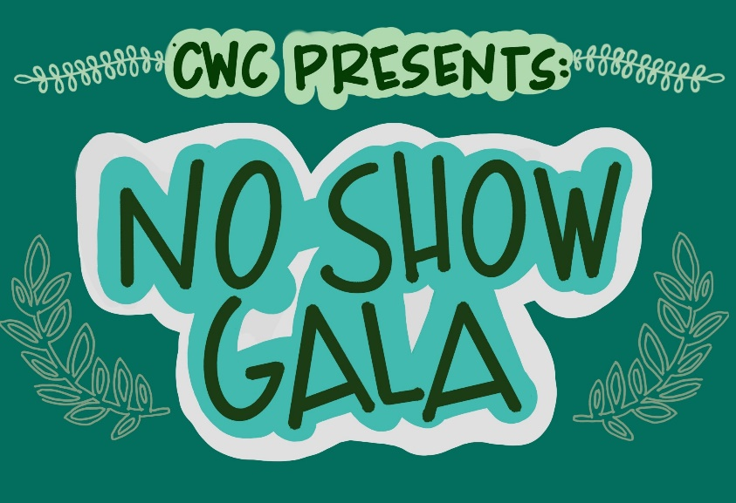
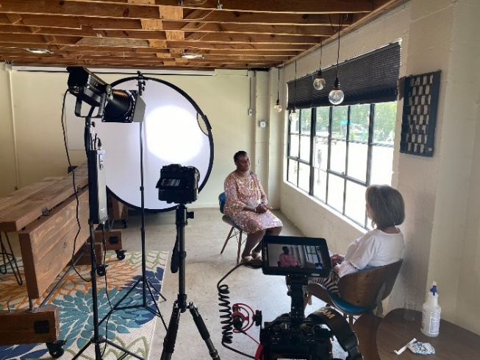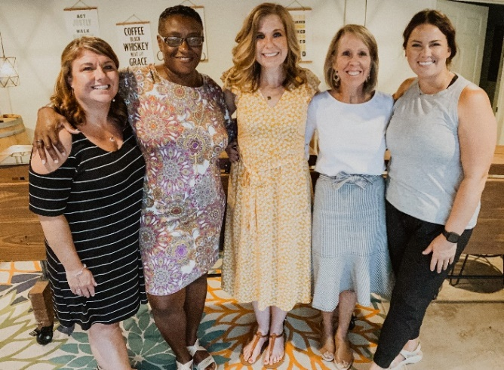

Our golf tournament is our second largest fundraiser. We were fortunate to have a beautiful fall day and we were able to set a new record in proceeds.
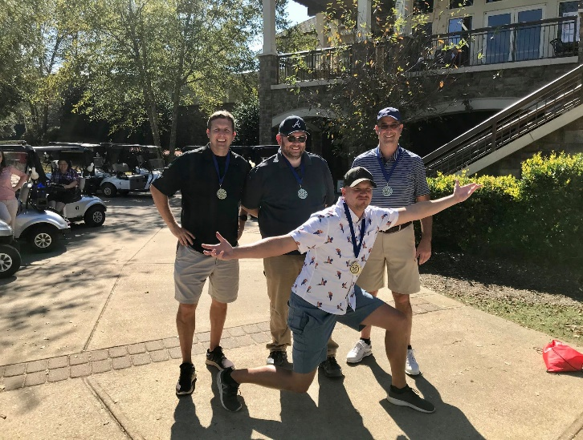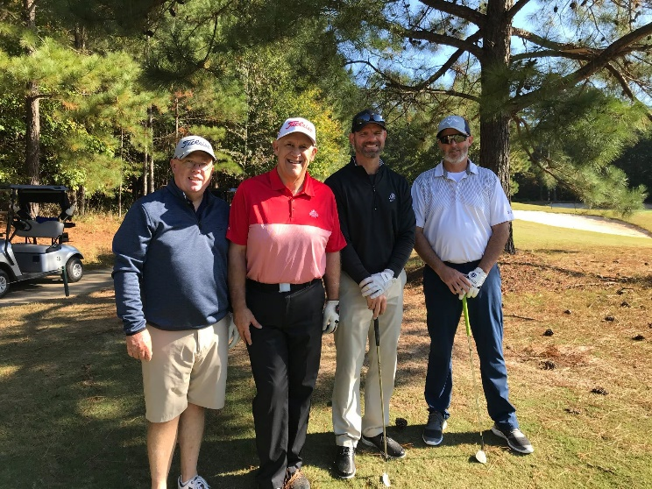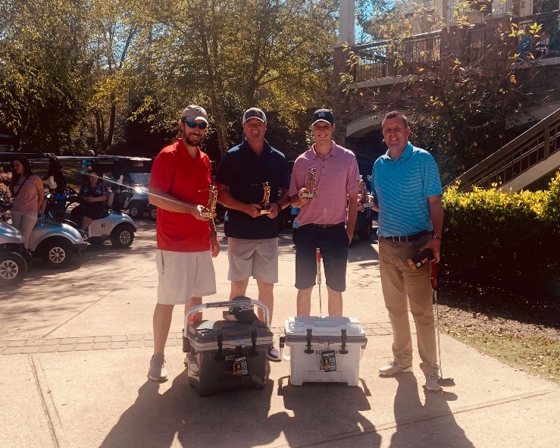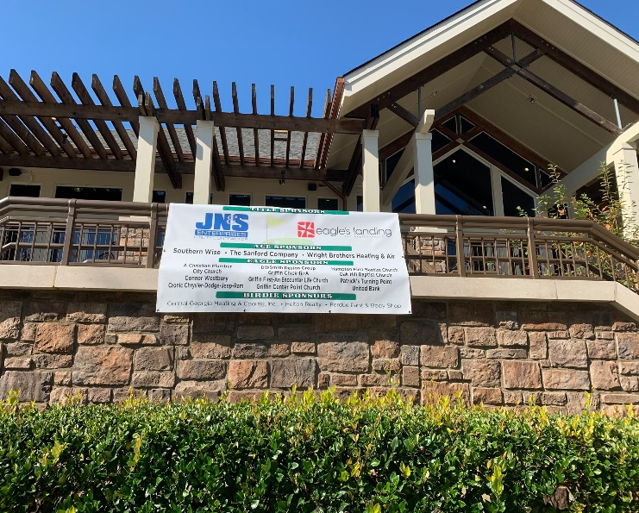
Sun City, Peachtree hosted our annual golf tournament in 2020.

Strategy Information
2020 was another great year for us financially. In spite of being shut down for 8 weeks at our stores, we had a net gain of $29,195.44. The gain was due to conservative financial decisions and good stewardship. And, we were awarded a Payroll Protection Plan loan that was completely forgiven. We are so thankful for God’s provision that allowed us to finish the year in a strong financial position.

We Need You
To put it simply, we are always in need of prayer. We understand that prayer is not about changing God’s mind, but about aligning ourselves with His will. This ministry exists only to give Him glory….and that is our greatest desire. This ministry could not thrive without our obedient financial partners. We never take for granted the many people and businesses who give to us because they trust that we will do what we say. We want you to know that we will be faithful stewards of all that God provides here at the CWC.
Your Donation is More Important Than Ever Before
With the ever-growing problem of drug and alcohol addiction (particularly the opioid crisis), this ministry is needed more than ever. Though we finished the year with a surplus, much of that was due to a few significant one-time donations, donations we cannot count on for 2021. There are several ways you can make a financial donation to the CWC. When you visit www.cwcga.org, you will see a donor page. Simply choose the Click and Pledge icon to be connected to our secure site. Donations by mail should be made to: Christian Women’s Center, PO Box 773, Sunny Side, GA 30284.

Physical donations are always needed as well. For a complete list of our needs, please visit our website at www.cwcga.org.

Volunteerism/You Can Make a Difference
We realize that not everyone can make a financial donation. We have many opportunities to give through volunteering.
Bible Study Teachers/Facilitators – Must have a minimum of two years verifiable experience in a local church or ministry. Bible studies can include topics such as Identity in Christ, Love of Christ, and Forgiveness. Volunteers should be available one day per week with a minimum six-month commitment.
Life Skills Teachers/Facilitators – This can include budgeting, meal planning, general computer skills, or any other life skill that would benefit our residents.
Creative Arts Volunteer – Works with Resident Service Staff in implementing various creative art projects for our residents.
Health and Nutrition Volunteer – Coordinates with other volunteers and Resident Service Staff to assist residents with meal plans, exercise, and healthy eating habits. Volunteers need some background in the Health and/or Nutrition field.
Health Care Volunteer – Provides medical, dental, counseling, or nursing assistance to residents off-site. Must be licensed in field and insured accordingly.
Maintenance Volunteer – Will come as needed, with a minimum six-month commitment, to perform regular maintenance such as painting, plumbing, electrical, etc. If performing any electrical or plumbing, volunteers must be licensed and insured. Volunteers must complete a maintenance form for the Executive office when providing service.
Lawn and Garden – Will assist with lawn care and teach gardening skills to residents. While we do our own lawn maintenance as much as possible, there are times when we need a little help.
Mentor – Women who will come alongside our ladies to help them grow spiritually, mentally and emotionally. Mentors are required to attend an initital volunteer training and updates for continuing education. Also, a Mentor must be available for natural mentoring relationships to form with residents by working with them to study for G.E.D., Driver’s License, Post-Secondary applications, FAFSA, etc.
Board of Directors – Will serve as a governing board member for the CWC Board of Directors for a period of 3 years. Oversee the budgeting, programming, and other aspects of the ministry. Serve as a liaison in the community and help with fundraising. Attend 6 meetings per year.
Transportation Assistance - Residents need assistance with transportation to appointments, classes, and sometimes work. The volunteer would work with Resident Services Staff to schedule.
Please visit our website at www.cwcga.org to learn more and complete the volunteer application. You can fax the completed form to 678-688-3842 or send it to our office at PO Box 773, Sunny Side, GA, 30284. (Please note: Applying does not guarantee we will have a volunteer opportunity available). We require a background check from all volunteers. We provide this service for a fee of $18.

Wish List
Many people ask us how they can help with donations of food, etc. Below is a list of ongoing needs at the CWC and our thrift stores.

Grocery food items: coffee, butter, sugar, creamer, milk, fruit, grits, oatmeal, eggs, vegetables, lettuce, breakfast meats, sandwich meats, blocks of cheese
Cleaning products: liquid or pod laundry detergent (powder is not allowed in our machines) and dishwashing liquid (not dishwasher).
Paper products: toilet paper, paper towels, napkins, tissues, copier paper, and spiral notebooks.
Items for the Thrift Store to sell: furniture, home decor, clothing, baby items, electronics, etc.

Advocacy Matters
If you or your group would like to partner with the CWC to give, volunteer, or offer a service, please contact Becky Smith or Michele Hendrix at 770-227-3700 and we’ll be happy to talk with you about ways you can help. We are always in need of partnering dentists, doctors, churches and businesses. You might be surprised at what you have to offer.

Looking Forward
Thankfully, we were able to fully fund our store operations (overhead) and provide 20% of the funds needed to run the WOW ministry. Our goal in 2021 is to raise our sales by 10%.
We were also able to reduce our mortgage debt by over 20%. Our ultimate financial goal for 2021 is to retire the debt on the residence in Sunny Side.

Programs: We realize that our program really does work if a woman is committed to life change. We are committed to continuing to take a critical look at our methods and evaluate what changes should be made.

Transportation: We have a 21 year old, 7 passenger van that needs replacing. We pray that 2021 will provide the financial resources to meet this need.

